Meditation Practice Booklet

Happiness is an Inside Job

Shakyamuni Buddha Guru Yoga Practice
Visualization: Imagine that your Guru appears before you in the aspect of Shakyamuni Buddha seated upon a beautiful, jeweled throne. Buddha’s holy body is golden in color and adorned with robes of heavenly silks. He is smiling lovingly at you.
Refuge and Bodhicitta.
I go for refuge, until enlightenment
To the Buddha, Dharma and Sangha
By my virtuous actions of giving and so on
May I become a Buddha to benefit all beings (3x)
The Four Immeasurables
May all beings have equanimity, free of attachment and aversion
May all beings have happiness, and the causes of happiness
May all beings be free of suffering, and the causes of suffering
May all beings find good rebirths, and the bliss of liberation
The Seven Limb Prayer
I prostrate with body, speech and mind
I make each and every offering
I confess my mistaken karma
And rejoice in every virtuous deed
Please Buddha stay until samsara ends
Teach Dharma to every sentient being
I dedicate to great enlightenment
Request Blessings to achieve every level on the Path to Enlightenment
May I be inspired by Guru devotion,
Uplifted by the preciousness of this human life,
Shed the fetters of attachment and aversion through a knowledge
of impermanence,
Be protected by refuge,
Guided by a knowledge of actions and their results,
Aim for liberation through renunciation.
May I be motivated by Bodhicitta,
Opened by giving,
Disciplined by ethical behavior
Strengthened by patience,
Enthused by joyous effort,
Stabilized by concentration,
And freed by wisdom.
Offering of the Universe (Mandala)
This ground scented with perfume and covered with flowers,
adorned by Mt. Meru, four worlds, sun, and moon,
I imagine as a Buddha land and then offer it.
May all beings enjoy this pure land.
I send this jeweled mandala to you, my precious guru.
Visualization
As you recite Shakyamuni Buddha’s mantra, light beams radiate from his heart. They enter your heart, removing obstacles, granting realizations on the path to enlightenment and filling you with warm, loving wisdom energy.
Know you are loved.
Shakyamuni Buddha’s Mantra
TAYATHA OM MUNI MUNI MAHA MUNIYE SOHA (7x)
Receiving the guru’s blessings
O magnificent and precious root guru
Please abide on the lotus and moon seat at my heart
Guide me with your great kindness
And stay with me always
Until I achieve enlightenment.
Smiling lovingly, Guru Buddha melts into a small sphere of light which comes to the crown of your head, descends to your heart, and blesses your mind. Pause for meditation then dedicate.
Shakyamuni Buddha’s mantra:
One translation of Shakyamuni Buddha’s mantra is a play on his name. Muni means sage. Maha means great. So, the mantra reads “Om wise one, wise one, greatly wise one, wise one of the Shakyans, Hail!”
Lama Zopa Rinpoche suggests that the Muni, Muni, Mahamuniye has the connotation of mastering the three scopes.
TAYATA OM MUNI MUNI MAHAMUNIYE SVAHA…
TAYATHA – it is like this
OM – body, speech, and mind
MUNI – lower scope (seeking positive future rebirths)
MUNI – middle scope (seeking freedom from samsara)
MAHAMUNIYE – upper scope (seeking full enlightenment)
SVAHA – so be it.
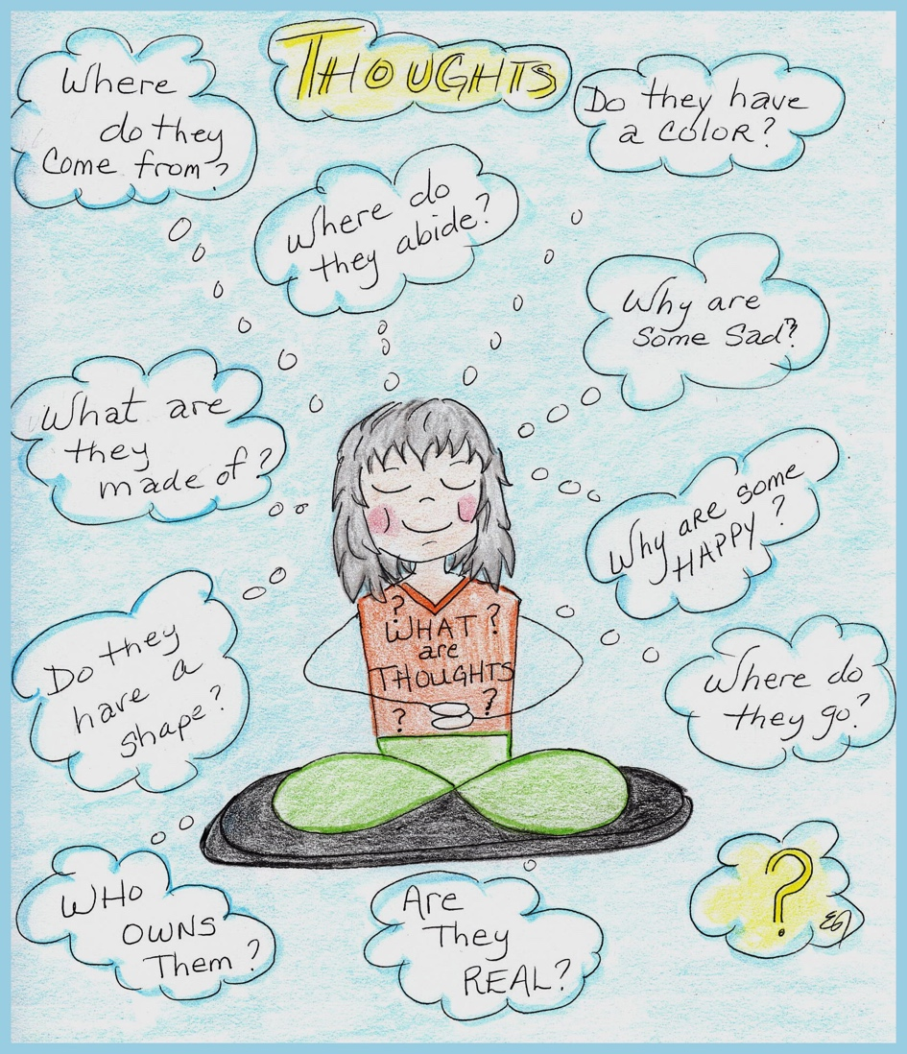

Taking a trip inside our mind, using meditation as the vehicle, we begin to unravel how the mind fabricates its experience of the world.
Meditation simply means to become familiar.
Everything we think, feel, say, or do, creates an experience. Ultimately, depending on awareness and attention, as well as knowing what to adopt and what to abandon, we can completely transform our experience of the world.

The Seven-Point Meditation Posture
- Legs: Crossed in full, half lotus or one leg in front of the other. Sitting on a firm cushion, raising the buttocks higher than the knees may help keep the spine straight. It may also help you to sit for longer periods of time without your feet and legs falling asleep.
It is also perfectly acceptable to meditate while sitting on a chair, using a low meditation bench, or in the supine position. It is mostly important to find a suitable position in which you can remain comfortable, relaxed, still and vigilant.
- Arms: Hands held loosely in your lap, right hand resting in the palm of your left, palms upward, thumbs lightly touching. Shoulders and arms should be relaxed. Arms should be slightly akimbo, leaving a bit of space between your arms and your body to allow air to circulate. This helps to prevent sleepiness during meditation.
- Back: Your back is most important – hold it straight, relaxed and lightly upright, as if the vertebrae are a stack of blocks, effortlessly resting in a pile. This helps your energy flow freely and enhances clarity and alertness of mind in meditation.
- Eyes: Even though in the beginning, it is often easier to concentrate with your eyes fully closed, it is recommended that you learn to leave your eyes slightly open to admit a little light and that you direct your gaze downwards, while not focusing on anything in particular. It may also be beneficial to have the eyes open.
- Jaw and Mouth: Your jaw and mouth are relaxed with your teeth slightly apart, not clenched, lips lightly touching.
- Tongue: Your tongue rests lightly on your upper palate with its tip lightly touching the back of the upper teeth.
- Head: Your head is just slightly inclined forward so that your gaze is directed naturally toward the floor in front of you.
Partially excerpted from material in Kathleen McDonald’s, “How to Meditate,”
Wisdom Publications, 1984.

How to Practice:
Clean your meditation space and set up an altar – frees your mind of clutter and makes the place “holy” or special/sacred.
Make offerings – a remedy to miserliness. Generosity gives great joy when we imagine our offerings being received with pleasure.
Assume the meditation posture – After making 3 prostrations, sit in the 7-point posture which helps the energy flow within the body. Then settle into relaxation, stillness, and vigilance through the power of breath.
Set your motivation to reach your highest human potential – full enlightenment – recalling your good fortune in having this precious human life, knowing it will not last, and wishing to use it in a meaningful way.
Invoke the Merit field – See your Guru in the aspect of an Enlightened being. Depending on the practice you are doing, they might manifest as Shakyamuni Buddha, Tara, Chenrezig, Lama Tsong Khapa, etc.
Take refuge, generate bodhicitta, and offer a mandala – When we offer the mandala, we’re offering a beautiful, perfect world with everything we love…we offer that.
Offer the Seven Limb Prayer
Make Requests – Requesting blessings that we might use this precious human life to actualize Buddhahood.
Receive the Guru’s blessings.
Believe and rejoice in being blessed. Sit one-pointedly in stillness, perfectly awake, perfectly aware.
Dedicate the positive energy created.

The Complete Path
Whatever you want for yourself and others
With a human form is easily attained;
Disengage yourself from meaningless efforts,
Strive to accomplish the highest goals.
Because all things composite are impermanent,
Life changes and never abides;
That change is the basis of suffering,
For the samsaric mind fills with frustration
On watching its creations continually fade.
The higher you climb in samsara,
The higher the cliff on which you perch;
The more things you own,
The tighter you are bound.
The dearer you hold someone,
The greater the chance they will hurt you.
The faster you subdue enemies,
The faster their numbers increase.
This body is a thing borrowed for a moment,
And possessions are things stored for others.
Now we dally with them,
But quickly are they lost and misused,
And only are sources of misery.
Therefore, no worldly possession
Is worth the effort of gaining.
Turn your back on that which only handicaps:
An unburdened mind is joy supreme.
The pinnacle of aims is to follow this path:
Body, speech and mind kept stainless with pure self-discipline,
Mind held in samadhi blissful and clear,
And wisdom seeing all realities of every situation.

The mother beings wandering in the six realms,
To me, their child, are pieces of my heart.
For many times have they soothed my troubles
And in infinite ways have they brought me joy.
These infinite beings, so kind,
Are covered by the fog of ignorance.
Constantly lashed by whips of delusions,
They have no chance to lay down
The burden of misery from their minds.
Therefore, whenever you meet anyone,
Greet them with eyes smiling with love.
Why mention that you should not even consider
Holding evil intentions or deceptive thoughts?
The way people and things seem to be,
Other than projected labels,
Is a distortion created by deluded mind.
If we look at the root of things,
Emptiness is clearly understood.
And in the vast space of perception of emptiness,
Mental grasping for the ultimate subsides.
Then one looks into the face of the world,
Everything is seen without essence.
Understanding inter-dependence we understand emptiness,
Understanding emptiness, we understand inter-dependence;
This is the view which is the middle,
And which is beyond the terrifying cliffs of
Eternalism, nihilism, neither or both.

The Complete Path was composed by the 7th Dalai Lama and translated by
Glenn Mullin.

Dedication
By merit of this virtue
May I become Buddha and
Lead all beings, everyone
Into that enlightened state.
Bodhicitta
May the precious Bodhi mind
Not yet born arise and grow
And may that born not decline
But increase more and more.
Long Life Prayer for His Holiness the Dalai Lama
In the snowy mountain paradise
You’re the source of good and happiness
Powerful Tenzin Gyatso, Chenrezig
Please remain until samsara ends.
Long Life Prayer for Lama Zopa Rinpoche
Great upholder of the moral way
The bountiful bearer of all good
Sustaining and spreading Buddha’s word
Expounding magnificent prayers
Kyabje Zopa, the great Rinpoche,
Protecting disciples please live long.
White Tara’s Long-Life Mantra for All our Gurus
OM TARE TUTARE TURE GURU ARYUR PUNYE JNANA PUSHTIM KURU SVAHA (3x)

Master Shantideva’s Prayer
May all beings everywhere
Plagued by sufferings of body and mind,
Find an ocean of happiness and joy
By virtue of my merit.
May no living creature suffer,
Commit evil or ever fall ill.
May no one be afraid or belittled
With a mind weighed down by depression.
May the blind see forms,
The deaf hear sounds.
May those whose bodies are worn with toil
Be restored on finding repose.
May the naked find clothing,
The hungry find food.
May the thirsty find water
And delicious drinks.
May the poor find wealth,
Those weak with sorrow find joy.
May the forlorn find hope,
Constant happiness and prosperity.
May there be timely rains
And bountiful harvests.
May all medicines be effective
And wholesome prayers bear fruit.
May all who are sick and ill
Quickly be freed from their ailments.
Whatever diseases there are in the world,
May they never occur again.
May the frightened cease to be afraid
And those bound be freed.
May the powerless find power
And may people think of benefiting each other.
As long as space remains,
As long as sentient beings remain,
There too, may I remain
To dispel the misery of the world.
Nine Stages of Meditation
Tibetan | Step | What is achieved | Power by which that is achieved
sem jok-pa  mind placing | Placing the mind/  Directed attention | Able to direct attention to the chosen object | Learning the instructions
gyun-du jok-pa  in a stream placing | Placement with continuity/  Continuous attention | Attentional continuity on the object up to one minute | Thinking about the practice
len-te jok-pa  patch placing | Patch-like placement/  Resurgent attention | Swift recovery of distracted attention, mostly on the object | Mindfulness
nye-war jek-pa  closely placed | Close placement/  Close attention | One no longer completely forgets the object | Mindfulness which is now strong
dul-war je-pa  taming it – to do it | Controlling/  Tamed Attention | One takes satisfaction in samadhi | Introspection
shi-war je-pa  peace make it | Pacifying/  Pacified Attention | No resistance to training the attention | Introspection
nam-par shi-war je-pa  totally peace make it | Thoroughly pacifying/  Fully pacified attention | Pacification of attachment, melancholy, and lethargy | Enthusiasm
tse chek-tu je-pa  one pointed make it | Making one-pointed/  Single-pointed attention | Samadhi is long, sustained, without any excitation or laxity | Enthusiasm
nam-pa jok-pa  even placing | Placement with equanimity/  Attentional balance | Flawless samadhi is long, sustained effortlessly | Familiarity

from Alan Wallace’s book, “Attention Revolution.”
Three Levels of Excitation or Dullness
Coarse: The attention completely disengages from the meditation object. Distractions –> Forgetting –> Mind Wandering.
Medium: Involuntary thoughts occupy the center of attention, while the meditative object is displaced to the periphery.
Subtle: The meditative object remains at the center of attention, but involuntary thoughts emerge at the periphery of attention.
The Six Powers
Listening/Study: Placing the mind is accomplished through listening to meditation instructions.
Reflection: Placement with continuity is accomplished through reflection and contemplation.
Mindfulness: Patch-like placement is accomplished by continuously resettling and fully settling the mind. Whenever one is distracted, one gathers the mind and slowly, through habituation, non-distraction occurs.
Awareness: Through close placement, one accomplishes controlling, pacifying and completely pacifying the mind. With joy for awareness and seeing the faults of succumbing to thoughts and negative emotions, one no longer falls prey to them.
Diligence: Through diligence, one accomplishes complete pacification and one-pointedness. Even subtle thought and negative emotions are abandoned.
Complete Familiarity: The final stage of resting in equanimity where the mind is unaffected by the obstacles of dullness or agitation is accomplished through complete familiarity.

Master Kamalashila (740-795 CE) was an Indian Buddhist at Nalanda Monastary. He described the nine stages of meditation leading to calm abiding.
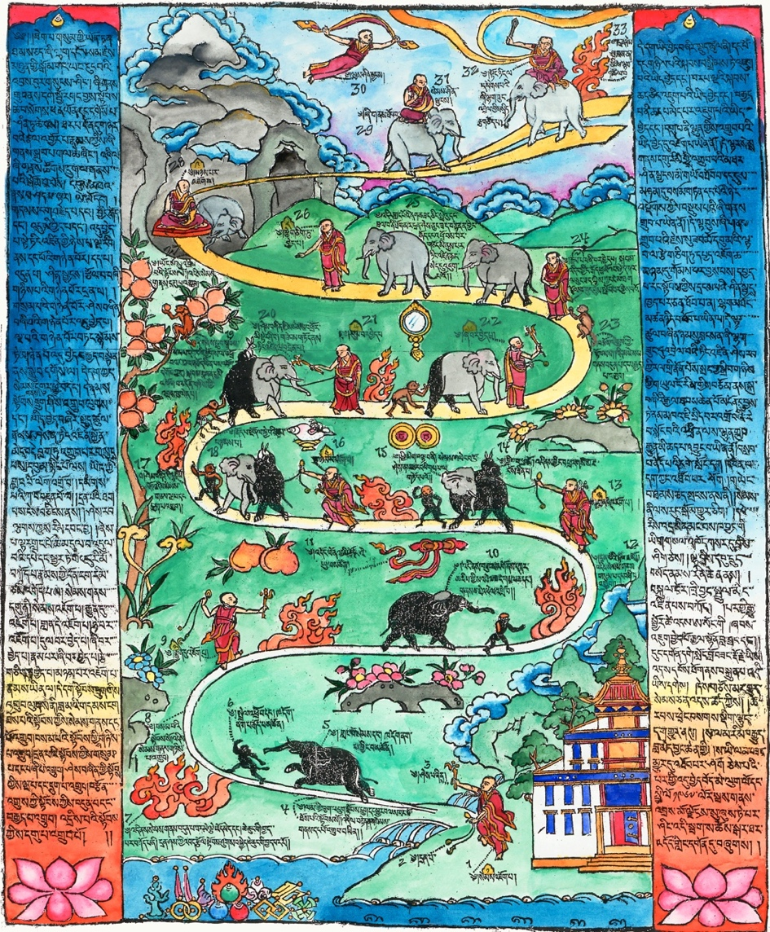
Drawing by Kyabje Trijang Rinpoche, colorized by Alexandra Emmons.

This woodblock print, pictured above depicts the stages, lists the steps, and offers advice. Kyabje Trijang Rinpoche, tutor to His Holiness the 14th Dalai Lama, created the drawing above. He taught that “If you practice these instructions correctly, then you will gain the razor-sharp sword of wisdom, a form of one-pointed concentration where quietude and special insight are married together.”
Drawing Explained
The monk is the meditator. The rope he holds represents vigilant, alert mindfulness. The goad in his other hand represents strong intention and firm resolve.
The elephant represents the mind. The black color of the elephant represents the hinderances and the problems which the hinderances give rise to. The gradual increase in the white patch on the elephant, starting with its crown, represents a gradual increase in the clarity and fixation of the mind.
The monkey represents scattering of attention, and the black color represents subtle and gross distraction, forgetting, mind-wandering and agitation. The monkey looking back represents the ability to both tell when your mind is wandering, and to re-focus it upon the object of meditation. When you are trying to develop quietude, even allowing your mind to be distracted to a virtuous object becomes an obstacle, and you must seek to stop it. And we see the monkey reaching for the fruit of another activity.
The rabbit represents subtle dullness.
The flames represent vigilance and effort, and when effort is no longer required, the flames disappear.
The length of the road between successive stages indicates the relative time required to progress from one stage to the next. The stages come closer together until stage seven, then they begin to stretch out again. Because the road folds back, it is possible to jump up to higher stages and fall back to lower ones. There are six bends in the road which represent the six powers (listening/studying, reflection, mindfulness, awareness, diligence, and familiarity).
The power of complete habituation enables you to reach the ninth mental state which is reaching deep meditation characterized by quietude, as well as physical and mental pleasure.
Calm abiding is attained when Special Insight and Quietude marry together.

Engaging in the Nine Stages of Calm Abiding
First, engage in the preliminaries and begin with breath meditation.
1. Placing the mind: This is trying to bring the mind onto the object in the first place. The whole session is spent bringing the mind to the object because most of the time it’s away.
2. Placement with continuity: You can stay for a little while before losing the object again. There is some continuity. Before, there was no continuity at all; you just placed your mind and “poof,” it goes off; you bring it there and it goes off. Now there is some continuity.
3. Patch-like placement: You can stay on the object for quite a while. From time to time you lose it, but then as soon as you lose it, you are aware that you are losing it, and you can bring your attention back.
4. Close placement: At the fourth stage, from the beginning to the end of your session, you can hold the object. There still is excitation or distraction and dullness, but one part of your mind never loses the object.
5. Controlling: On the previous level, you were able to stay for the whole session on the object. Because the object is there, stable, and clear, there is now the danger of relaxing your effort and being prone to subtle laxity or dullness. By familiarizing yourself with the object, you reach a state of inner peace you have never experienced before. It’s like your mind was always like boiling water. Suddenly, the boiling water has subsided, and you find your mind experiences a kind of tranquility you never had before. You realize: “Wow, that’s quite pleasant!”
The difference between the fifth and the fourth levels is that at the fifth level there is no more gross laxity and gross excitement.
6. Pacifying: Here you are able to recognize with introspection even subtle excitement and laxity as a fault. What is missing is the intensity of holding on to the object. In general, when you reach this stage, it is better to lean towards the side of subtle excitement than to lean toward the side of subtle laxity because subtle excitement is easier to recognize.
7. Thoroughly pacifying: You can stay on the object continuously. When subtle excitement and laxity arise, you can easily stop them. However, you still need strong effort. You sit there and stay on the object. From time to time you must check to see if excitement or laxity has arisen, but in the bulk of your sitting, you are constantly aware of the object.
Excitement and dullness are not so strong anymore. They don’t happen often and even if they arise, you just have to “poof” and the subtle thought or subtle emotion will stop.
Actually, it is a process of going from your ordinary mind, which is full of mental activity, to going into a mind of peace. It is like entering into a tunnel or entering into something. You focus your mind on the object and you go through certain stages to go into the mind of calm abiding.
8. Making one-pointed: Here you just need a little effort at the beginning of the session to control subtle excitement and laxity, but then it becomes a free ride. The whole session of meditation happens without interruptions from these dullness or excitement.
9. Placement with equanimity: Here, there is no more effort. As soon as you sit down, you are so familiar with the state of meditation that you just sit down, and you are in there for the whole session. No matter how long, you can stay on the object without any excitement or any dullness. That’s a fantastic state of mind!
This is the ninth stage of calm abiding; it is not the fully qualified calm abiding yet.
You must cultivate this placement with equanimity for some time, after which there is a transformation of your body and mind. There is a kind of physical bliss, which arises, and a mental bliss. This physical and mental bliss give rise to a special physical suppleness, or pliancy, or lightness about your body and a lightness about your mind: a sharpness, a suppleness about the mind, a pliancy where you can apply your mind toward anything virtuous you want, whenever you want. The mind always has great enthusiasm. You never lose enthusiasm for doing something positive.
10. Calm Abiding: When physical and mental bliss have arisen, conjoined with physical suppleness and mental suppleness which is stabilized, this is called “calm abiding.”

Remembering
Remembering the kindness of mothers
may I always work for their benefit
and never bring them harm.

Colophon: This booklet was created by Elaine Jackson. Much of the information contained herein comes from notes taken during Ven. René Feusi’s Shamatha teachings at Vajrapani Institute. Dedicated to the cultivation of love for all beings.
Additional References:
“Attention Revolution” by Dr. Alan Wallace
“The Mind Illuminated” by Dr. John Yates
“How to Meditate” by Kathleen McDonald

